
1. Overview

This proposal outlines the development of a private, intranet-hosted dashboard designed to monitor the health status of Daikibo’s industrial machines. The dashboard will provide real-time visibility into 9 machines across each of Daikibo’s 4 factories, leveraging existing telemetry data to deliver a centralized view of device health. Accessible exclusively within the client’s intranet and integrated with Daikibo’s internal authentication server, the solution will enable authorized users to quickly assess machine statuses, review historical health data, and streamline equipment monitoring workflows—all through a single, user-friendly interface.
2. Scope

1. Intranet Access Control: The dashboard will be hosted exclusively on Daikibo’s internal intranet, ensuring external access is blocked and data security is maintained.
2. Integrated Authentication: User access will be synced with Daikibo’s internal authentication server, allowing employees to log in using their existing company-wide credentials (no new accounts required).
3. Real-Time Machine Health View: A single-page layout displaying the current health status of all 36 monitored devices (9 machines × 4 factories), with clear visual indicators for healthy, degraded, or critical statuses (consistent with Template Graphic 1: Dashboard Main View).
4. Collapsible/Expandable Hierarchy: The interface will support expansion/collapse at two levels:
- Factory level: Expanding a factory reveals all 9 machines within that location.
- Device level: Expanding a machine displays its historical health status timeline (consistent with Template Graphic 2: Expanded Factory/Device View).
5. Telemetry Data Integration: The dashboard will pull real-time and historical telemetry data (e.g., temperature, operation status) to populate machine health statuses and history, aligning with Template Graphic 3: Historical Status Timeline.
Out of scope: External cloud hosting, third-party authentication systems, machine control/automation capabilities and non-telemetry data integration (e.g., maintenance logs).
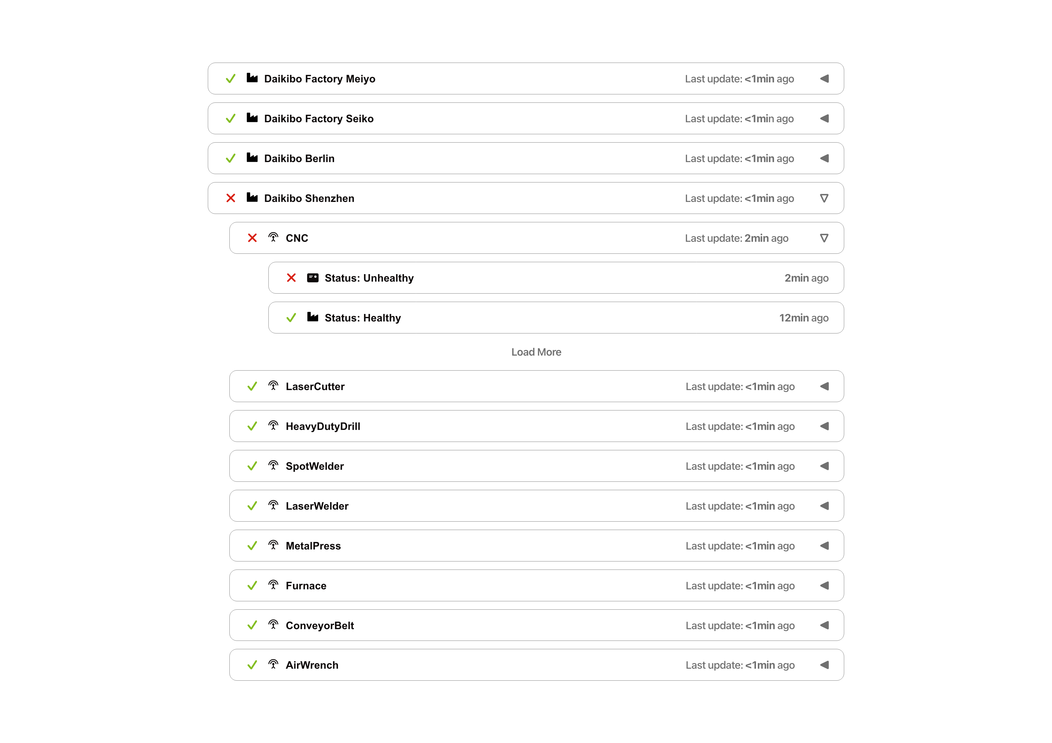
3. Estimate

Total Estimated Man-Hours: 120 hours

Phase | Description | Man-Hours
Development | Frontend UI development (single-page layout, collapsible views, status indicators), backend integration (telemetry data pull, intranet hosting), authentication server sync | 70
Testing | Functional testing (authentication, status display, expand/collapse), compatibility testing (intranet browsers), load testing (simultaneous user access), bug identification and resolution | 30
Integration | Final integration with Daikibo’s intranet, authentication server, and telemetry data sources; user acceptance testing (UAT) support | 20

4. Timeline

The project will follow a structured timeline with clear milestones, totaling 4 weeks (20 business days):
- Milestone 1: Project Initiation & Setup (Days 1–2)
- Finalize requirements alignment with Daikibo stakeholders
- Set up development environment and intranet access
- Establish authentication server integration parameters
- Milestone 2: Core Development (Days 3–10)
- Develop frontend dashboard layout and expandable/collapsible views
- Integrate telemetry data pull for real-time and historical statuses
- Implement authentication server sync
- Milestone 3: Testing & Bug Fixes (Days 11–16)
- Conduct functional and compatibility testing
- Resolve identified bugs and optimize performance
- Prepare for UAT with Daikibo users

- Milestone 4: Integration & Deployment (Days 17–19)
- Integrate dashboard with Daikibo’s intranet and telemetry systems
- Complete UAT and address final feedback
- Deploy the dashboard to the intranet
- Milestone 5: Handover & Training (Day 20)
- Provide user training for dashboard navigation and functionality
- Hand over documentation and support resources
- Confirm successful deployment and stakeholder sign-off

5. Support

Daikibo can rely on continuous post-deployment support to ensure the dashboard remains operational and aligned with evolving needs. Our support services include:

- Bug Fixes: Priority response (24-hour turnaround for critical issues, 48-hour for non-critical) to resolve any technical glitches or performance issues.
- Support Tickets: A dedicated support channel for Daikibo users to submit questions, report issues, or request guidance on dashboard usage.
- Enhancement Support: Collaboration with Daikibo to evaluate and implement new functionality (e.g., additional telemetry metrics, custom status alerts) as needed, with transparent estimates for any scope expansions.
- Periodic Check-Ins: Monthly follow-up to review dashboard performance, address feedback, and ensure the solution continues to meet monitoring needs.

